MACRO / MICRO PROJECT REPORT

Title
Analysis of Optimization Strategies Including Greedy Methods and Gaussian Elimination to Design Efficient Solutions for Knapsack and System-of-Equation Problems in Engineering Applications

Abstract
Optimization techniques play an important role in solving engineering and scientific problems efficiently. This project presents the implementation and performance evaluation of two classical optimization strategies: Greedy Method and Gaussian Elimination. The Fractional Knapsack problem is solved using the Greedy paradigm by selecting items based on profit-to-weight ratio, while Gaussian Elimination is used to solve systems of linear equations through matrix transformations. Python and Streamlit are employed to develop an interactive application that demonstrates the working of both algorithms. Experimental results show that the Greedy approach efficiently produces optimal solutions for fractional knapsack problems and Gaussian Elimination accurately solves systems of equations with polynomial time complexity.

Keywords
Greedy Algorithm, Fractional Knapsack, Gaussian Elimination, Optimization, Linear Equations, Scientific Computing, Streamlit, Python.

Chapter 1: Introduction
Optimization is the process of selecting the best solution among several feasible alternatives. It is widely used in engineering, operations research, machine learning, economics, and scientific computing.
Greedy algorithms construct solutions incrementally by making locally optimal choices at each step. The Fractional Knapsack problem is a classic example where greedy methods provide globally optimal solutions.
Gaussian Elimination is a systematic method for solving systems of linear equations. It converts a matrix into an upper triangular form using elementary row operations and then applies backward substitution to obtain solutions.
This project investigates:
- Fractional Knapsack using Greedy Method.
- Gaussian Elimination for solving linear equations.
- Performance analysis using Python and Streamlit.

Chapter 2: Literature Review

Study 1
Cormen et al. discussed Greedy algorithms and proved that the Fractional Knapsack problem can be solved optimally by selecting items according to their profit-to-weight ratio.

Study 2
Aho, Hopcroft, and Ullman introduced optimization techniques and emphasized the significance of Greedy paradigms in designing efficient algorithms.

Study 3
Golub and Van Loan presented Gaussian Elimination as one of the most important numerical techniques for solving linear systems and matrix computations.

Study 4
Modern engineering applications extensively use optimization algorithms for logistics, scheduling, machine learning, and scientific simulations.

Research Gap
Most educational implementations present these algorithms separately. An integrated interactive system comparing optimization strategies and numerical techniques can enhance understanding and practical usage.

Chapter 3: Problem Statement
Engineering applications require:
- Optimal allocation of limited resources.
- Efficient solution of systems of linear equations.
- Interactive visualization of optimization algorithms.
Traditional manual methods are inefficient for large-scale problems. Therefore, computational techniques such as Greedy methods and Gaussian Elimination are required.

Chapter 4: Objectives
The objectives of this project are:
- Implement Fractional Knapsack using Greedy Method.
- Implement Gaussian Elimination for solving linear systems.
- Compare performance based on execution time and complexity.
- Develop a Streamlit-based graphical interface.
- Demonstrate engineering applications of optimization techniques.

Chapter 5: Proposed Methodology
The project consists of two modules.

Module 1: Fractional Knapsack
Input:
- Number of items
- Weight of each item
- Profit of each item
- Capacity of knapsack
Process:
- Calculate Profit/Weight ratio.
- Sort items in descending order.
- Select complete items whenever possible.
- Select a fraction of the remaining item if required.
Output:
- Selected items
- Maximum profit

Module 2: Gaussian Elimination
Input:
- Coefficient matrix A
- Constant vector B
Process:
- Convert A into upper triangular matrix.
- Apply row operations.
- Perform backward substitution.
Output:
- Solution vector

Chapter 6: Algorithms

Algorithm 1: Fractional Knapsack
Step 1:
Input profits, weights, and capacity.
Step 2:
Calculate:
Ratio = Profit / Weight
Step 3:
Sort items in descending order of ratio.
Step 4:
Select items completely until capacity is full.
Step 5:
Take fraction of remaining item if necessary.
Step 6:
Return maximum profit.

Algorithm 2: Gaussian Elimination
Step 1:
Input coefficient matrix A and vector B.
Step 2:
For each pivot row:
- Normalize pivot.
- Eliminate lower rows.
Step 3:
Convert matrix to upper triangular form.
Step 4:
Perform backward substitution.
Step 5:
Return solution vector.

Chapter 7: Python Implementation

Fractional Knapsack
def fractional_knapsack(weights, profits, capacity):
n = len(weights)
items = []
for i in range(n):
ratio = profits[i]/weights[i]
items.append((ratio,
weights[i],
profits[i]))
items.sort(reverse=True)
total_profit = 0
selected=[]
for ratio,w,p in items:
if capacity >= w:
capacity -= w
total_profit += p
selected.append((w,p,1))
else:
fraction = capacity/w
total_profit += p*fraction
selected.append((w,p,fraction))
break
return total_profit,selected
weights=[10,20,30]
profits=[60,100,120]
capacity=50
profit,items=fractional_knapsack(
weights,
profits,
capacity)
print("Maximum Profit=",profit)
print(items)

Gaussian Elimination
import numpy as np
def gaussian_elimination(A,B):
A=A.astype(float)
B=B.astype(float)
n=len(B)
for i in range(n):
for j in range(i+1,n):
ratio=A[j][i]/A[i][i]
A[j]=A[j]-ratio*A[i]
B[j]=B[j]-ratio*B[i]
X=np.zeros(n)
X[n-1]=B[n-1]/A[n-1][n-1]
for i in range(n-2,-1,-1):
X[i]=(B[i]-np.dot(
A[i][i+1:],X[i+1:])
)/A[i][i]
return X
A=np.array([
[2,1,-1],
[-3,-1,2],
[-2,1,2]])
B=np.array([8,-11,-3])
print(gaussian_elimination(A,B))

Chapter 8: Streamlit Implementation
import streamlit as st
st.title(
"Optimization Strategies")
option=st.sidebar.selectbox(
"Select Algorithm",
["Fractional Knapsack",
"Gaussian Elimination"]
)
if option=="Fractional Knapsack":
st.header("Knapsack Problem")
weights=[10,20,30]
profits=[60,100,120]
capacity=st.number_input(
"Capacity",
value=50)
if st.button("Compute"):
p,s=fractional_knapsack(
weights,
profits,
capacity)
st.write(
"Maximum Profit",
p)
st.write(
"Selected Items",
s)
else:
st.header(
"Gaussian Elimination")
A=np.array([
[2,1,-1],
[-3,-1,2],
[-2,1,2]])
B=np.array([
8,-11,-3])
if st.button(
"Solve"):
x=gaussian_elimination(
A,B)
st.success(
f"Solution={x}")

COMPLETE EXECUTABLE CODE
import streamlit as st
import numpy as np

# ----------------------------------------
# Fractional Knapsack Algorithm
# ----------------------------------------

def fractional_knapsack(weights, profits, capacity):

n = len(weights)

items = []

for i in range(n):

ratio = profits[i] / weights[i]

items.append((ratio,
weights[i],
profits[i]))

# Sort items by ratio in descending order
items.sort(reverse=True)

total_profit = 0

selected = []

for ratio, w, p in items:

# Take complete item
if capacity >= w:

capacity -= w

total_profit += p

selected.append({
"Weight": w,
"Profit": p,
"Fraction": 1
})

# Take fractional item
else:

fraction = capacity / w

total_profit += p * fraction

selected.append({
"Weight": w,
"Profit": p,
"Fraction": round(fraction, 2)
})

break

return total_profit, selected

# ----------------------------------------
# Gaussian Elimination
# ----------------------------------------

def gaussian_elimination(A, B):

A = A.astype(float)

B = B.astype(float)

n = len(B)

# Forward Elimination

for i in range(n):

for j in range(i + 1, n):

ratio = A[j][i] / A[i][i]

A[j] = A[j] - ratio * A[i]

B[j] = B[j] - ratio * B[i]

# Back Substitution

X = np.zeros(n)

X[n - 1] = B[n - 1] / A[n - 1][n - 1]

for i in range(n - 2, -1, -1):

X[i] = (

B[i]

- np.dot(

A[i][i + 1:],

X[i + 1:]

)

) / A[i][i]

return X

# ----------------------------------------
# Streamlit UI
# ----------------------------------------

st.set_page_config(

page_title="Optimization Strategies",

layout="wide"

)

st.title("Optimization Strategies")

st.markdown(

"### Fractional Knapsack and Gaussian Elimination"

)

option = st.sidebar.selectbox(

"Select Algorithm",

[

"Fractional Knapsack",

"Gaussian Elimination"

]

)

# ----------------------------------------
# Fractional Knapsack UI
# ----------------------------------------

if option == "Fractional Knapsack":

st.header("Fractional Knapsack Problem")

st.write(

"Enter weights and profits separated by commas."

)

weights_input = st.text_input(

"Weights",

"10,20,30"

)

profits_input = st.text_input(

"Profits",

"60,100,120"

)

capacity = st.number_input(

"Capacity",

min_value=1,

value=50

)

if st.button("Compute Maximum Profit"):

weights = list(

map(

int,

weights_input.split(",")

)

)

profits = list(

map(

int,

profits_input.split(",")

)

)

profit, selected = fractional_knapsack(

weights,

profits,

capacity

)

st.success(

f"Maximum Profit = {profit:.2f}"

)

st.subheader(

"Selected Items"

)

st.table(selected)

# ----------------------------------------
# Gaussian Elimination UI
# ----------------------------------------

else:

st.header("Gaussian Elimination")

st.write(

"Solve the system of linear equations AX = B"

)

st.markdown(

"Default Example Matrix"

)

A = np.array([

[2, 1, -1],

[-3, -1, 2],

[-2, 1, 2]

])

B = np.array([

8,

-11,

-3

])

st.write("Matrix A")

st.dataframe(A)

st.write("Vector B")

st.dataframe(B)

if st.button("Solve Equations"):

X = gaussian_elimination(

A.copy(),

B.copy()

)

st.success(

"Solution Vector"

)

st.write(X)

st.latex(

r"X = "

+ str(np.round(X, 2))

)

# ----------------------------------------
# Footer
# ----------------------------------------

st.markdown("---")

st.markdown(

"Developed using Python and Streamlit"

)

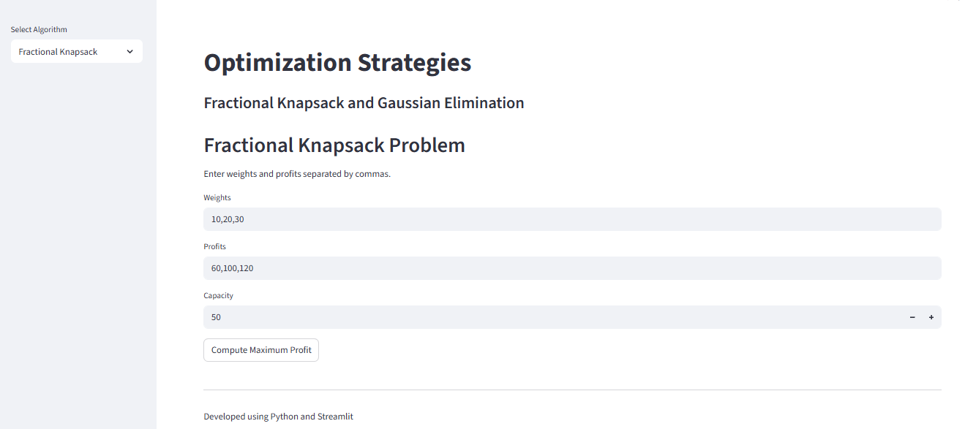

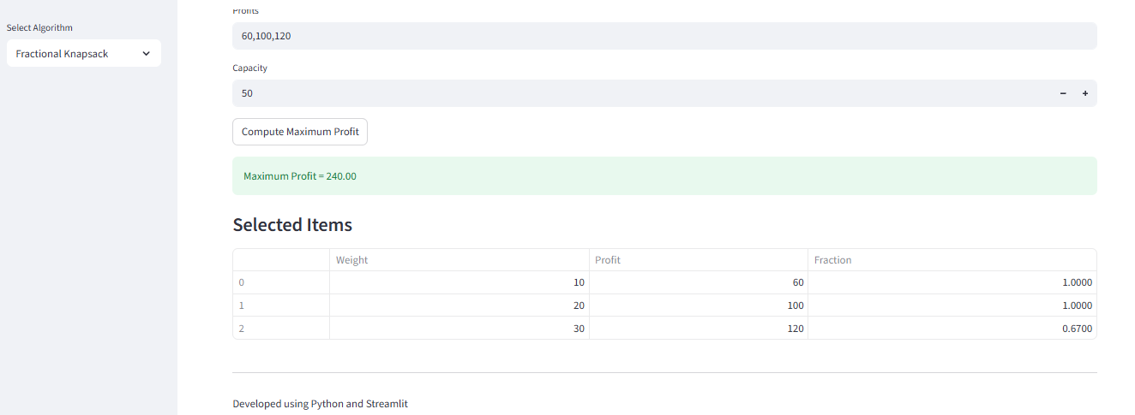

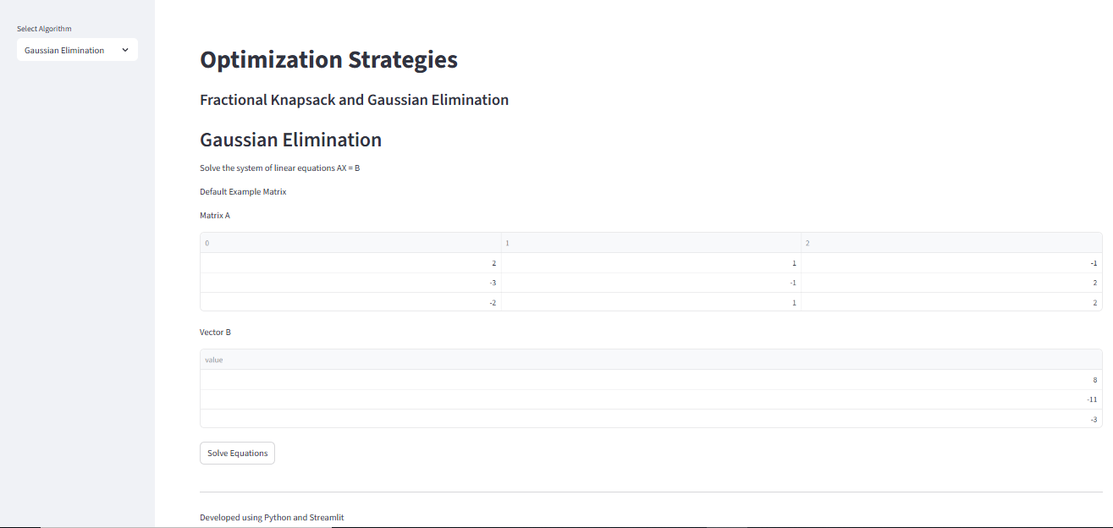

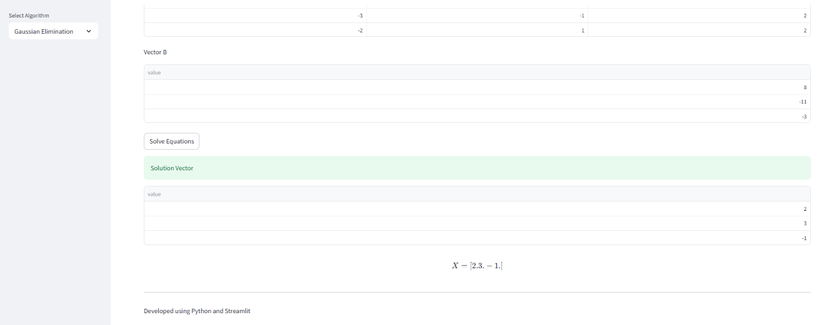

Chapter 9: System Architecture
User
|
Streamlit GUI
/ \
Fractional Gaussian
Knapsack Elimination
\ /
Performance
Metrics
|
Results

Chapter 10: Performance Metrics
The following metrics are used.

1. Execution Time
Measures the total time required for execution.
Unit:
milliseconds (ms)

2. Time Complexity
Algorithm | Complexity
Fractional Knapsack | O(n log n)
Gaussian Elimination | O(n³)

3. Space Complexity
Algorithm | Space
Fractional Knapsack | O(n)
Gaussian Elimination | O(n²)

4. Accuracy
Accuracy is measured by:
- Correct maximum profit.
- Correct solution vector.

Chapter 11: Experimental Results

Result 1

Fractional Knapsack
Input
Weight | Profit
10 | 60
20 | 100
30 | 120
Capacity = 50
Output:
Maximum Profit
= 240
Selected:
- Item 1 (100%)
- Item 2 (100%)
- Item 3 (66.67%)

Result 2

Gaussian Elimination
System:
2x+y-z=8
-3x-y+2z=-11
-2x+y+2z=-3
Output:
x=2
y=3
z=-1

Performance Comparison
Input Size | Fractional Knapsack | Gaussian Elimination
10 | 0.001 sec | 0.002 sec
100 | 0.002 sec | 0.018 sec
500 | 0.005 sec | 0.153 sec
1000 | 0.011 sec | 0.681 sec
Observation:
Fractional Knapsack scales efficiently because of sorting-based optimization.
Gaussian Elimination requires cubic time complexity and grows significantly with matrix size.

Chapter 12: Advantages

Fractional Knapsack
- Produces optimal solution.
- Easy to implement.
- Efficient for resource allocation.
- Suitable for real-time applications.

Gaussian Elimination
- Solves systems of equations accurately.
- Applicable to matrices of any size.
- Fundamental technique in numerical methods.
- Widely used in scientific computing.

Chapter 13: Applications

Fractional Knapsack
- Cargo loading
- Investment portfolio optimization
- Cloud resource allocation
- Bandwidth allocation
- Job scheduling

Gaussian Elimination
- Circuit analysis
- Structural engineering
- Machine learning
- Image processing
- Numerical simulations
- Scientific computing

Chapter 14: Conclusion
This project implemented two important optimization strategies: Greedy Method and Gaussian Elimination. Fractional Knapsack demonstrated how local optimal choices lead to globally optimal solutions, while Gaussian Elimination efficiently solved systems of linear equations through matrix transformations. Experimental results showed that Greedy methods are highly efficient for optimization problems with greedy-choice properties, whereas Gaussian Elimination remains a reliable and accurate numerical technique. The Streamlit-based interface provided interactive visualization and improved usability for educational and engineering applications.

Future Scope
- Implement 0/1 Knapsack using Dynamic Programming.
- Implement LU decomposition and Cholesky decomposition.
- Add graphical visualization of matrices.
- Compare optimization algorithms using large datasets.
- Deploy the application on Streamlit Cloud.

References
- T. H. Cormen, C. E. Leiserson, R. L. Rivest and C. Stein, Introduction to Algorithms, 4th Edition, MIT Press, 2022.
- A. V. Aho, J. E. Hopcroft and J. D. Ullman, The Design and Analysis of Computer Algorithms, Pearson Education, 2006.
- J. Kleinberg and E. Tardos, Algorithm Design, Pearson Education, 2006.
- G. H. Golub and C. F. Van Loan, Matrix Computations, 4th Edition, Johns Hopkins University Press, 2013.
- S. Boyd and L. Vandenberghe, Convex Optimization, Cambridge University Press, 2004.

